Table of Contents

Running an EEG Experiment: 2

1. Preparing the data: 4

*2. ConvertToHTK* 6

3. NeuralFindEvent 7

4. NeuralGenOut 8

5. Final Structure 9

6. Upload to Server 10

# Running an EEG Experiment:

**Before starting the experiment:**

**Caps and Electrodes:**

* Make sure that the cap is not folded and it is stretched.

- Cz should be at the middle of the head, approximately 20 Cm from A1 and 20 cm from A2. (Shown on the picture)

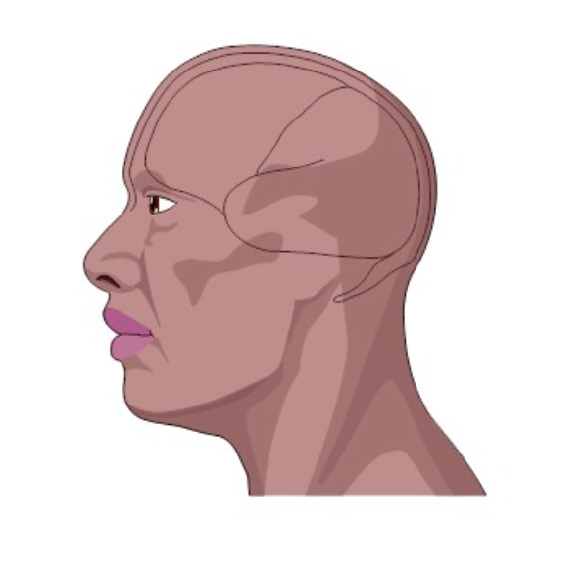

Cz

A1

A2

* Add gel and check the Impedance (open g.recorder/tools/impedancecheck), put gel in the ground and channel 1 at first. If you could not get green impedances for all the channels, save a snapshot of the impedance check.
* If you couldn’t get green impedance, lift the electrode a little and put gel under it, then fix the electrode.
* Connect the references to the ears. References should have gel too.

**To Subject:**

* It should be clarified for the subject that: 1. He shouldn’t move. 2. He should keep the eyes open during the experiment. 3. He should try to blink between the sentences.

**Hiamp Configuration:**

* Add 60Hz Notchfilter, 0 to 200 Hz bandpass.
* Add channel 64 as reference.

**During the Experiment:**

* Open g. Scope block in Simulink model.
* Check the analog channels.
* Check the eye-blinking effect on EEG, check the alpha power increase when the subject closes the eyes or when he is tired.

**Between the Experiments**:

* Make sure the subject is still concentrated.
* Check the impedances again.

**After the Experiment:**

* Wash each electrode of the cap separately without separating it from the cap. All the electrodes, wires and the cap are washable.
* Fill out the readme file, remove the unnecessary recorded data, and put all of them on the server.

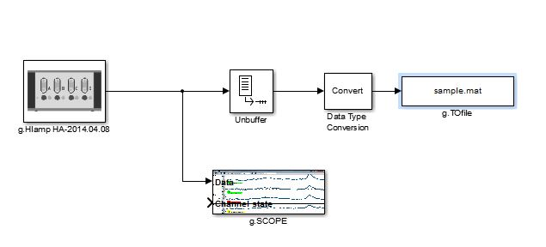

A simple simulink model

# 1. Preparing the data:

1. Create a folder named “CUEEGxx”, xx is the subject ID.
2. Put “CUEEGxx.xls” (information file) in the generated folder.
3. The name of the raw data should be “Bxx_ …”, xx is the block number.
4. Create a subfolder “original”, put the raw data and stimulus order in “original” folder.

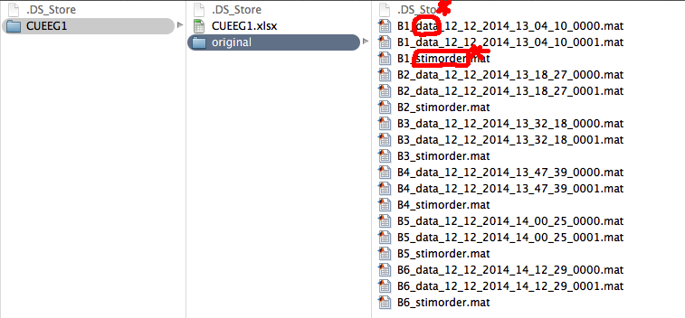

* ”stimorder” and “data” in the name of the .mat files are the cues of finding the data and stimorder, so remember to mention them in the name of your .mat files.

* Stimorder is a cell array containing the sounds names in the order that were played.

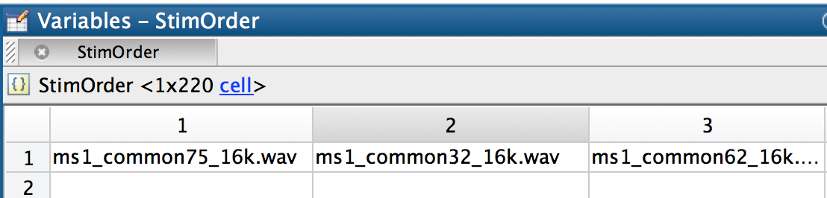

* Raw data ( for example: B1_data_12_12_2014_13_04_10_0000.mat) contains variable y(channel*time)
  + y(2:63,:) EEG data
  + y(64:65,:) references
  + y(66,:) analog channel -> recorded audio using hiamp

# 2. ConvertToHTK

Go to “CUEEGxx” folder and run ConvertToHTK(fs). The default Sampling rate is 2400Hz.

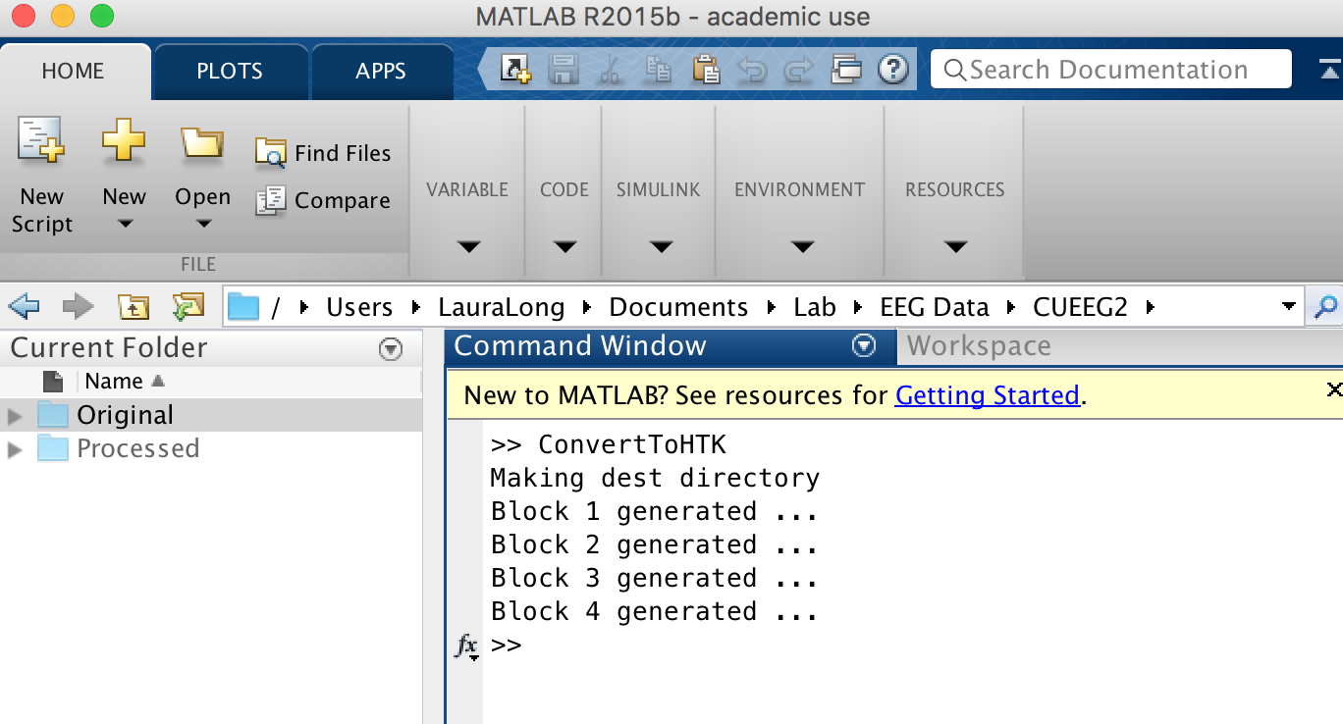

Or specify the original and destination folder:

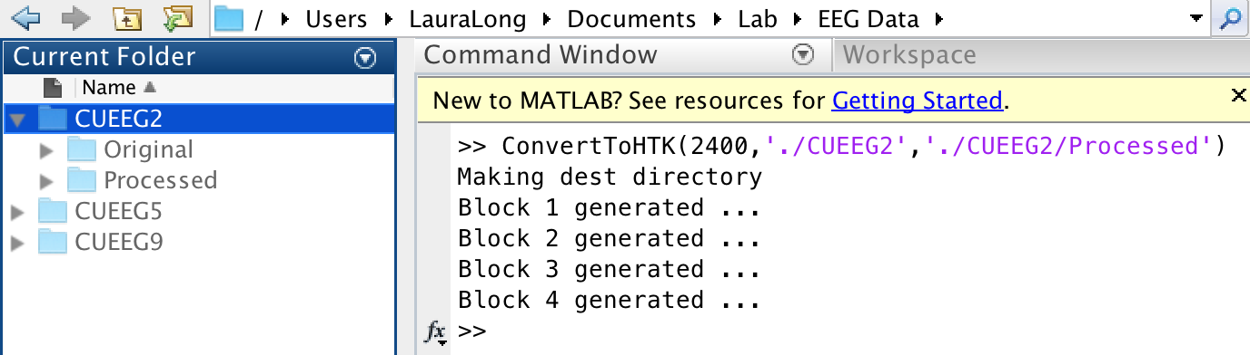

# 3. NeuralFindEvent

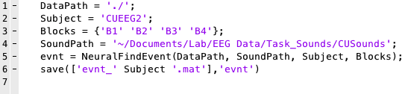

generated evnt:



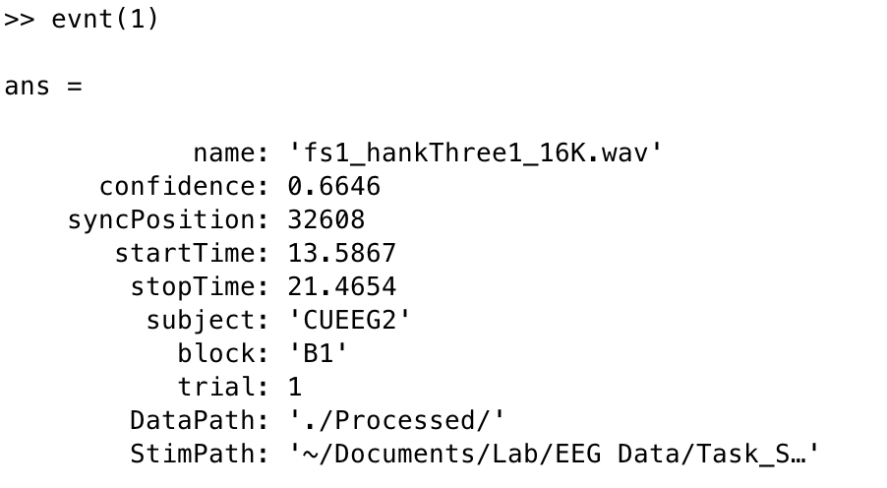

# 4. NeuralGenOut

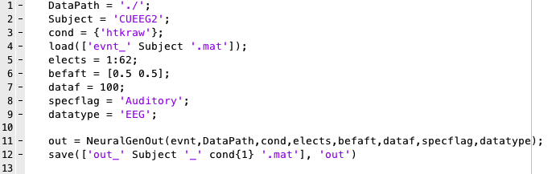

Generated Out:

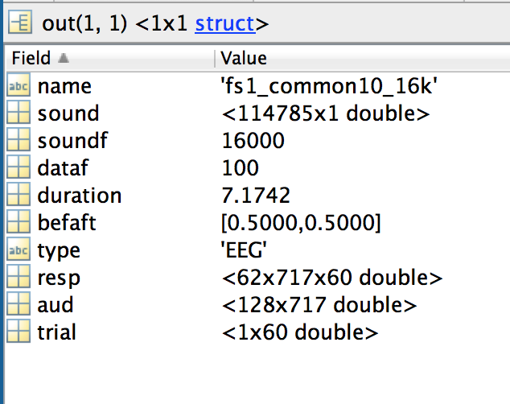

**aud** is the auditory spectrogram

**resp** is channel*time*trial

**trial** contains the corresponding indices of trials in evnt

**befaft** is the added silence before and after the sound

* sound doesn’t contain the silence, resp and aud does.

# Final Structure

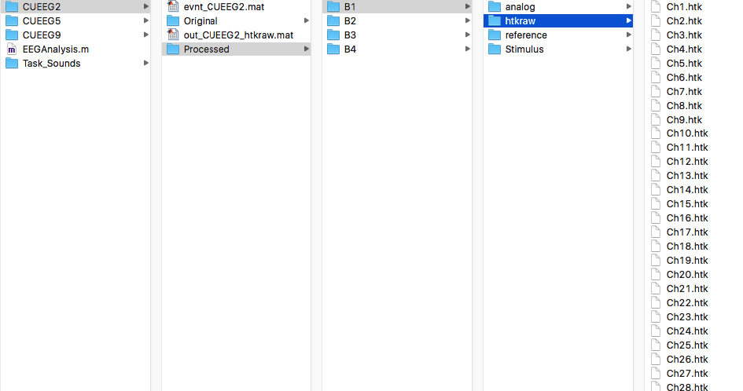

# Upload to Server

**Upload the subject file containing the above structure (Original, Processed, evnt, and out) to the server in the appropriate task folder:**

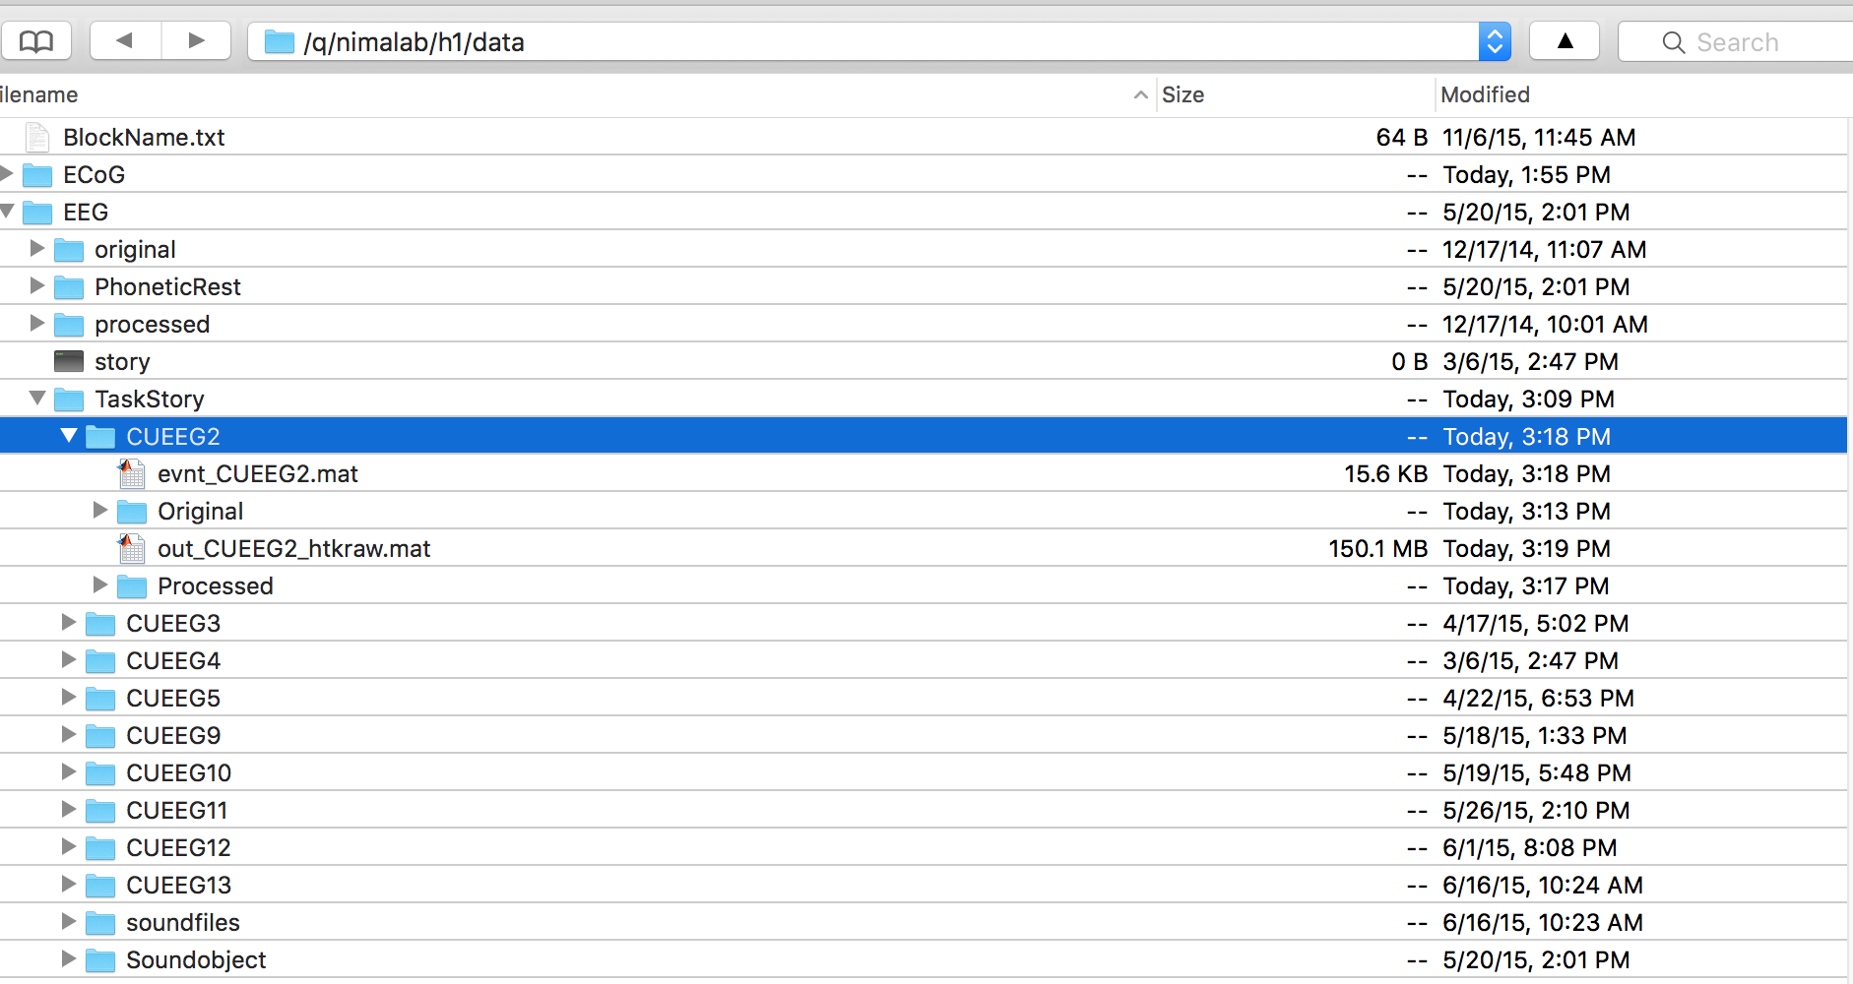

**q/nimalab/h1/data/EEG/taskfolder/CUEEGxx**